RESPONSE TO REQUEST FOR INFORMATION
Solicitation Number: 36C10B26Q0131
Replacement Model for VA.gov
Submitted to:
U.S. Department of Veterans Affairs
Technology Acquisition Center
Submitted by:
AENIGMA SOLUTIONS LLC
Service-Disabled Veteran-Owned Small Business (SDVOSB)
200 Sanatorium Rd, Suite 101
Glen Gardner, NJ 08826
February 5, 2026
Point of Contact | Company Information
Gregory Williams  Founder & CEO  gregapai@gmail.com  (845) 685-6682 | UEI: CXYSEFL5QF54  CAGE: 15PL3  NAICS: 541519  SDVOSB Certified

1. Company Overview
Aenigma Solutions LLC is a Service-Disabled Veteran-Owned Small Business (SDVOSB) headquartered in Glen Gardner, New Jersey. Founded in September 2025 by Gregory Williams, a former U.S. Army Ranger (1997-2001) with military intelligence background, Aenigma was established with a singular mission: delivering exceptional technology solutions to federal agencies, with particular focus on serving those who served.

1.1 Core Capabilities
- Custom Software Development: Full-stack web and mobile application development using modern frameworks including React, Node.js, Python, and cloud-native architectures
- Cloud Services: Design, migration, and management of cloud infrastructure across AWS, Azure, and Google Cloud Platform with emphasis on FedRAMP-compliant environments
- Cybersecurity: Security assessment, implementation, and continuous monitoring aligned with NIST frameworks and federal security requirements
- Digital Transformation: Modernization of legacy systems, API development, and user experience optimization for government agencies

1.2 Why a Veteran-Owned Firm for VA.gov
We believe that Veterans building for Veterans creates a uniquely powerful alignment of mission and capability. Our founder's firsthand experience navigating VA systems as a service-disabled veteran provides invaluable insight into the frustrations and needs of the end users VA.gov serves. This is not abstract empathy—it is lived experience that informs every design decision, every user flow, and every accessibility consideration.
Aenigma brings the discipline, adaptability, and mission-focus that military service instills. We understand that VA.gov is not merely a website—it is a lifeline for millions of Veterans seeking healthcare, benefits, and support. Downtime or poor user experience directly impacts those who have already sacrificed for their country.

2. Understanding VA's Challenge
The VA's recognition that replacing VA.gov requires more than technical work—that it demands coordination across experience design, platform architecture, content strategy, governance, and analytics—demonstrates sophisticated program thinking. We share this holistic view.

2.1 Key Challenges We Identify
- Scale and Continuity: VA.gov serves millions of users daily. Any modernization must ensure zero disruption to critical services including healthcare appointment scheduling, benefits claims, and prescription refills.
- Legacy Integration Complexity: The VA operates hundreds of backend systems, many built over decades. A modern frontend must seamlessly integrate with this diverse portfolio while not being constrained by its limitations.
- Identity and Authentication Friction: Current sign-in experiences involve multiple identity providers (Login.gov, ID.me, My HealtheVet) creating confusion. Streamlining this while maintaining security is paramount.
- Accessibility at Scale: Veterans include populations with higher rates of visual impairment, cognitive challenges, and physical disabilities. WCAG 2.1 AA compliance is a floor, not a ceiling.
- Mobile-First Reality: Significant portions of the Veteran population access services via mobile devices, often in areas with limited connectivity. Performance optimization is critical.
- Trust and Transparency: Veterans need confidence that their data is secure and their interactions are private. Any new platform must prioritize and communicate its security posture.

3. Technical Approach and Capabilities
Aenigma proposes a modular, phased approach to VA.gov modernization that allows for iterative improvement while maintaining service continuity. Rather than a risky "big bang" replacement, we recommend a strangler fig pattern where new capabilities gradually replace legacy components.

3.1 Recommended Architecture Principles
- Headless CMS Architecture: Decouple content management from presentation to enable omnichannel delivery (web, mobile app, chatbot, voice assistants) from a single source of truth.
- API-First Design: Build all services as APIs first, enabling both internal and future third-party integrations while maintaining security boundaries.
- Micro-Frontend Architecture: Allow independent teams to develop, test, and deploy discrete user experiences without system-wide coordination overhead.
- Event-Driven Integration: Use event streaming (Apache Kafka or AWS EventBridge) for loose coupling with legacy systems, enabling real-time data synchronization without tight dependencies.
- Progressive Web Application (PWA): Deliver native-app-like experiences through the browser with offline capability, push notifications, and home screen installation.
- Edge Computing: Deploy static assets and cacheable content to edge locations nationwide to minimize latency for Veterans in rural areas.

3.2 Recommended Technology Stack
Layer | Recommended Technologies
Frontend | React/Next.js with TypeScript, U.S. Web Design System (USWDS), Tailwind CSS
Backend Services | Node.js, Python FastAPI, GraphQL federation for unified data access
Cloud Platform | AWS GovCloud (FedRAMP High), with multi-region disaster recovery
Identity Layer | Unified identity broker integrating Login.gov, ID.me with SAML/OIDC
Content Management | Drupal (headless) or Strapi for structured content with editorial workflows
Analytics | DAP-compliant analytics, privacy-preserving user journey tracking

3.3 Identity and Authentication Approach
Addressing the complexity highlighted in Notice ID 365357 regarding next-generation digital identity, Aenigma recommends a unified identity broker architecture that provides Veterans with a single, streamlined sign-in experience while maintaining integration with existing identity providers.
- Single Entry Point: One "Sign In" button that routes to a unified selection interface, reducing cognitive load from current multi-option confusion.
- Identity Proofing Assistance: Guided identity verification with real-time support options including video chat for Veterans who struggle with automated proofing.
- Progressive Authentication: Allow basic information access with lower assurance levels, requiring stronger authentication only for sensitive transactions.
- Account Recovery that Works: Self-service recovery options that don't require remembering which provider was used originally.
- Persistent Session Management: Secure, long-lived sessions that don't require daily re-authentication while maintaining security.

4. User Journey: Identity Proofing and Sign-In
The following diagram illustrates our recommended user journey for the sign-in experience, designed to minimize friction while maintaining security. The flow accommodates both new users requiring identity proofing and returning users with streamlined authentication.
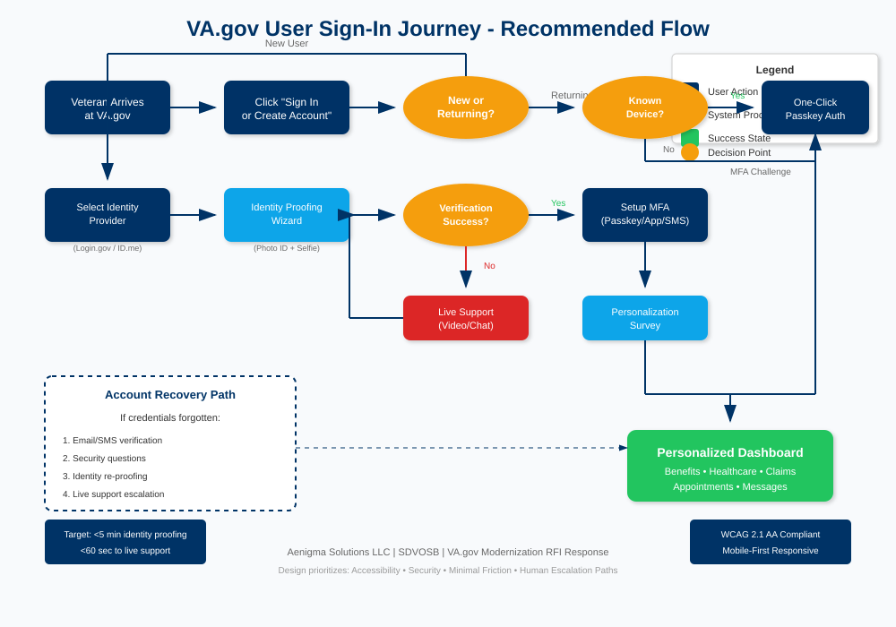
Figure 1: VA.gov User Sign-In Journey - Recommended Flow

4.1 Key Design Principles
- Single Entry Point: Veterans see one "Sign In" button regardless of their identity provider, reducing confusion.
- Recognized Device Fast-Path: Returning users on trusted devices authenticate with one click via passkey.
- Human Escalation Always Available: When automated processes fail, live support is available within 60 seconds.
- Recovery Without Dead Ends: Account recovery works regardless of which identity provider was originally used.
- Personalization on First Visit: New users complete a brief survey to personalize their dashboard experience.

4.2 Target Metrics
- Identity proofing completion: Under 5 minutes for 90% of users
- Returning user sign-in: Under 10 seconds with passkey
- Time to live support: Under 60 seconds from escalation request
- Account recovery success rate: Greater than 95% self-service resolution

5. Known Limitations, Risks, and Tradeoffs
Aenigma believes in transparent assessment of challenges. The following represents our honest evaluation of risks and tradeoffs:

5.1 Technical Risks
- Legacy System Dependencies: Many backend systems use outdated protocols or lack modern API interfaces. Significant integration work required.
- Data Migration Complexity: User data spread across multiple systems must be carefully consolidated without data loss or corruption.
- Performance at Scale: VA.gov experiences significant traffic spikes around benefit deadlines. Architecture must handle 10x normal load.
- Security Surface Expansion: Any modernization introduces new attack vectors that must be carefully managed.

5.2 Organizational Risks
- Change Management: VA staff across hundreds of facilities rely on current systems. Training and adoption support essential.
- Governance Coordination: Multiple VA administrations (VHA, VBA, NCA) have different priorities and requirements.
- Contractor Transition: Current contractors have institutional knowledge that must be transferred or retained.

5.3 Tradeoffs
- Speed vs. Stability: Aggressive modernization timelines increase risk; conservative approaches may frustrate stakeholders.
- Customization vs. Standardization: Meeting unique VA needs while leveraging standard components requires balance.
- Innovation vs. Accessibility: Cutting-edge features must not create barriers for less tech-savvy users.

6. Lessons Learned from Similar Deployments
Drawing from industry experience with large-scale government digital transformations, Aenigma identifies the following critical success factors:
- Start with User Research: Healthcare.gov's initial failure stemmed partly from insufficient user testing. Continuous user feedback loops are non-negotiable.
- Invest in DevSecOps: Automated testing, security scanning, and deployment pipelines catch issues before they reach production.
- Plan for Failure: Circuit breakers, graceful degradation, and comprehensive monitoring ensure system resilience.
- Communicate Constantly: Stakeholders, users, and staff need regular updates on progress, changes, and expectations.
- Measure What Matters: Define success metrics early (task completion rates, user satisfaction, error rates) and track relentlessly.
- Phase Ruthlessly: Resist scope creep. Deliver core functionality first, then iterate based on real user behavior.

7. Conclusion
Aenigma Solutions LLC welcomes the opportunity to support the VA's vision for a premier, modern, secure, and Veteran-centric digital experience. As a Service-Disabled Veteran-Owned Small Business, we bring not only technical capability but genuine understanding of the mission.
We are particularly interested in contributing to the identity and authentication modernization effort, mobile experience optimization, and accessibility enhancement—areas where our agile approach and Veteran perspective can deliver immediate value.
We would welcome the opportunity for follow-on discussions to explore how Aenigma can support VA's objectives. Thank you for your consideration.

— End of Response —

Aenigma Solutions LLC | 200 Sanatorium Rd, Suite 101, Glen Gardner, NJ 08826
Gregory Williams | gregapai@gmail.com | (845) 685-6682

